DriverPass System Design Document
Russell Buck
Southern New Hampshire University
CS‑255: System Analysis and Design
Professor Yurik
February 21, 2026

UML Diagrams

UML Use Case Diagram
Description
The use case diagram illustrates all the individuals and external systems that interact with DriverPass, along with the tasks each one needs to perform. This includes customers, the secretary, drivers, the IT officer, the owner, and the DMV system. The diagram shows how the system supports each role and ensures that all business needs are met.
DriverPass Use Case Diagram
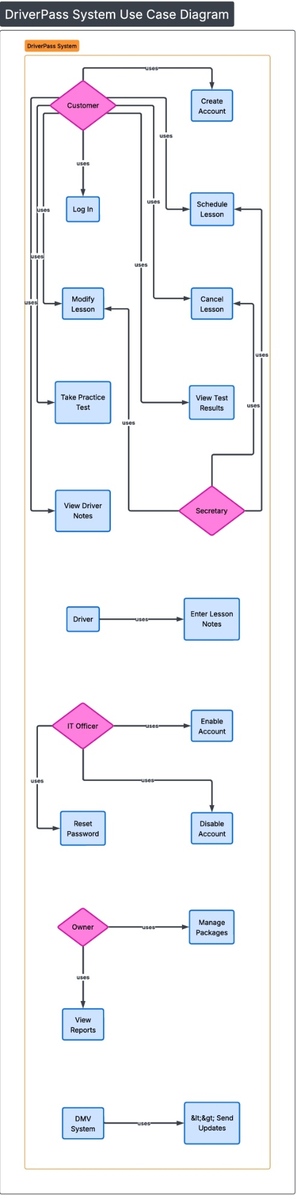
UML Activity Diagrams
Activity Diagram 1: Scheduling a Lesson
Description
This activity diagram shows the step‑by‑step process a customer follows to schedule a driving lesson. It includes logging in, selecting a time, checking availability, and confirming the appointment. The design ensures that customers only see available time slots and that double‑booking is prevented.
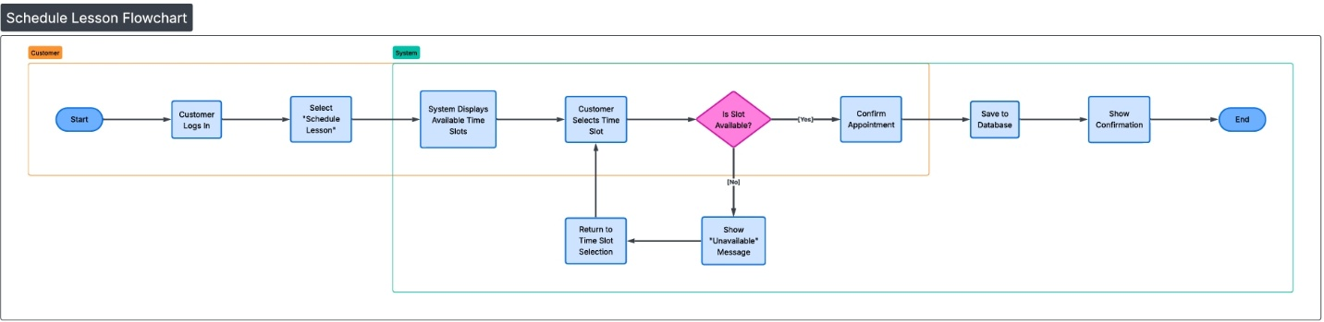
Figure 2
Activity Diagram: Scheduling a Lesson

Activity Diagram 2: Taking a Practice Test
Description
This diagram outlines the process a customer follows to complete a practice test. It includes selecting a test, answering questions, submitting the test, and viewing the final score and status.
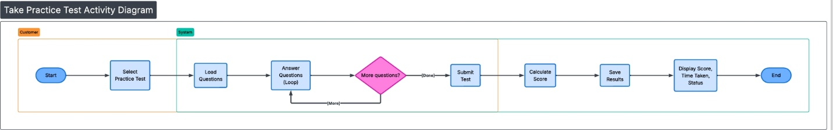
Figure 3: Activity Diagram: Taking a Practice Test

UML Sequence Diagram
Sequence Diagram: Scheduling a Lesson
Description
This sequence diagram shows how the customer, system, and database interact during the scheduling process. It includes requesting available time slots, checking availability, saving the appointment, and confirming the booking.
Figure 4
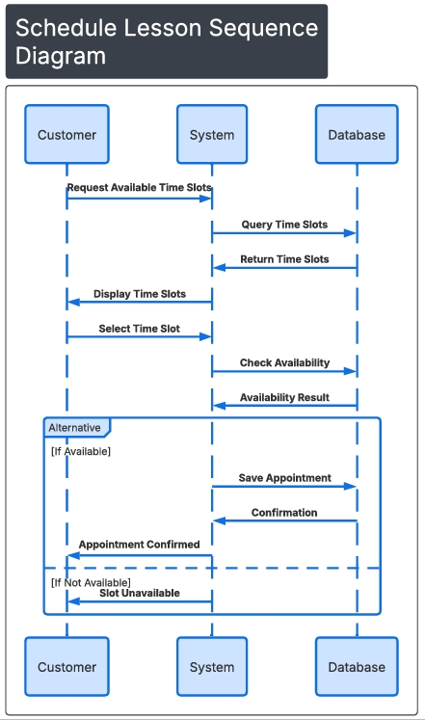
Sequence Diagram: Scheduling a Lesson

UML Class Diagram
Description
The class diagram outlines the main data structures used in the DriverPass system. It shows the key classes, their attributes, and how they relate to each other. This helps ensure the system is organized, scalable, and easy to maintain.
Figure 5
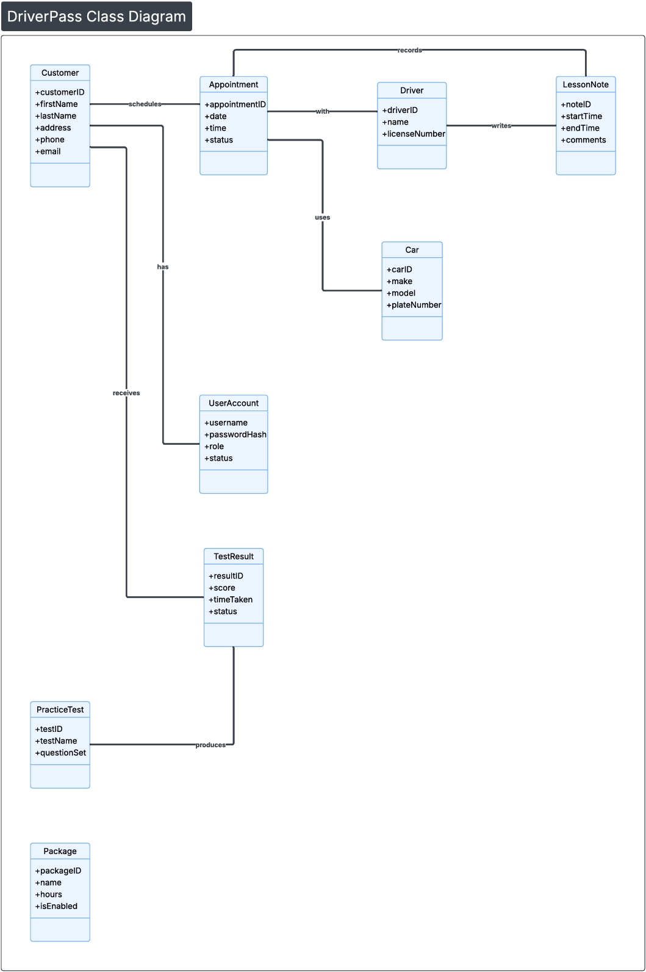DriverPass Class Diagram
Classes Included:
• Customer: customerID, firstName, lastName, address, phone, email
• Appointment: appointmentID, date, time, status
• Driver: driverID, name, licenseNumber
• LessonNote: noteID, startTime, endTime, comments
• Car: carID, make, model, plateNumber
• UserAccount: username, passwordHash, role, status
• TestResult: resultID, score, timeTaken, status
• PracticeTest: testID, testName, questionSet
• Package: packageID, name, hours, isEnabled
Relationships:
• Customer records Appointment
• Appointment schedules Driver
• Driver writes LessonNote
• Appointment has Car
• Customer receives UserAccount
• PracticeTest produces TestResult

.Technical Requirements
With DriverPass being a small business that may grow over time, the system is designed with scalability and reliability in mind. A cloud‑based server is recommended because it is cost‑effective, easy to maintain, and can expand as the business grows. All administrative staff should have access to computers running a modern operating system such as Windows to ensure compatibility with the system.
To protect sensitive customer and administrative information, the system should use automated backups and security software to prevent data loss or malicious attacks. A reliable internet connection is essential so staff can receive real‑time updates to schedules, reservations, and DMV policy changes.
The DriverPass web portal should be accessible on commonly used operating systems—including Windows, macOS, iOS, and Android—to ensure that customers can access the system from any device. This supports DriverPass’s goal of offering a convenient and user‑friendly experience.

